**HARSHTON JUNIOR SCHOOL – MBALE**

**TERM ONE HOLIDAY PACKAGE 2023**

**PRIMARY ONE ENGLISH**

**Pupil’s Name: …………………………………………………………….**

1. **Match the capital to small letters.**

A d

B e

C a

D b

1. **Write these words in small letters**.
2. HEN hen
3. KNIEF ______________
4. CAR ______________
5. TIN ______________
6. **Count and write the number in words**.

_________________ book. two

_________________ chairs three

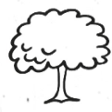_________________ trees four

one

1. **Fill in the missing letters.**

c ___ t

p ____ n

___ esk

1. **Write these words correctly.**
2. cpu ________________
3. school ________________
4. byo ________________
5. **Use article “a” or “an” to complete the following**

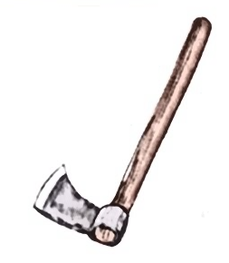

________________ ________________



________________

1. **Name the pictures below correctly.**

|  |  |  |
| --- | --- | --- |
|  |  | **D:\Esteem Jr Sch Documents\pictures\bottle.jpg** |
|  |  |  |

**(bottle, paper, ball, car, table)**

1. **Join the following words to form compound words.**

dust + bin dustbin

table + spoon ________________

sick + bay ________________

1. **Read and draw the following.**

|  |  |
| --- | --- |
|  |  |
| I am writing. | sister is sweeping the compound. |
|  |  |
| She is cooking food. | Teacher is teaching. |

1. **Underline the word for the picture.**

tree, ruler, head



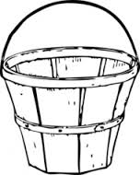book, pencil, glass

star, man, teacher

1. **Write these number words in figures.**

two 2

three _____________

five _____________

one _____________

1. **Arrange these words in ABC order.**
2. Car, ball, axe

______________________________________________

1. Egg, dog, flag

______________________________________________

1. **Give the now tense (ing)**

go going

stand _________________

eat _________________

1. 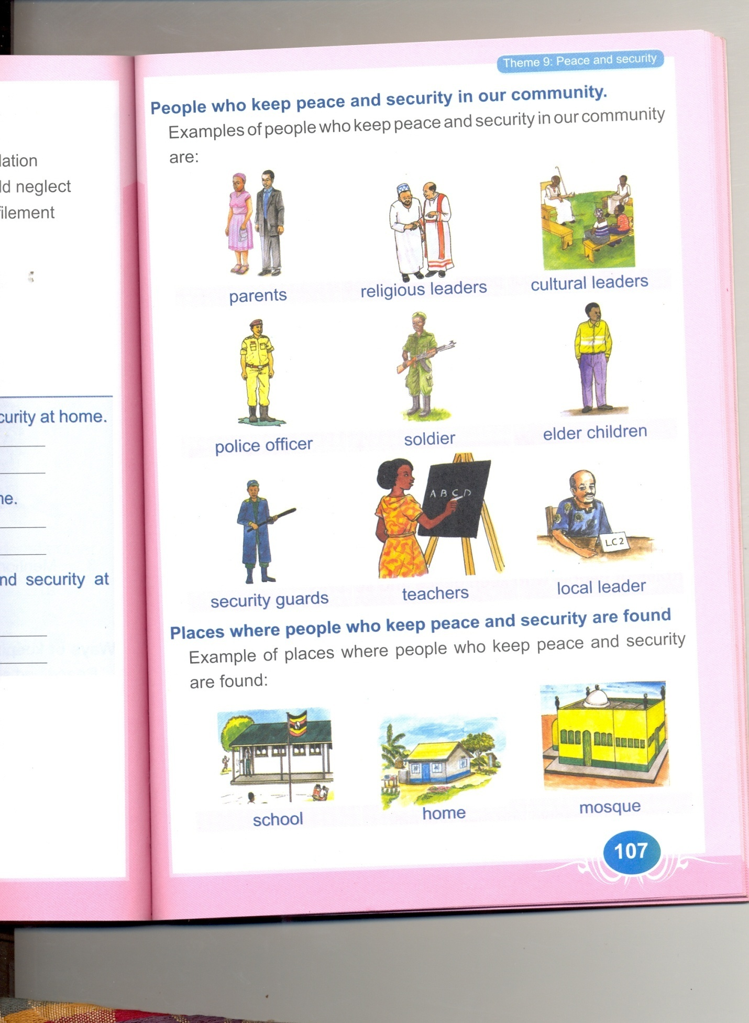**Complete the guided composition.**

**Every day, I go to ______________ in a**

**_____________ and at school, I use a**



**____________ and a ___________ when writing teacher’s work. I love school so much.**

**Pencil, school, book, car**

1. Draw these things found in your classroom.

|  |  |  |  |
| --- | --- | --- | --- |
| chalkboard | pen | desk | school bag |
|  |  |  |  |

1. Complete the sentences correctly.

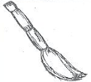

That is a ______________

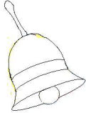

Here is a ______________

(broom, doctor, bell, taxi)

1. Give the opposite of these words.

girl __________________

out __________________

(come, boy, in, man)

**HARSHTON JUNIOR SCHOOL – MBALE**

**TERM ONE HOLIDAY PACKAGE -2023**

**PRIMARY ONE MATHEMATICS**

**Pupil’s Name: …………………………………………………………….**

**SECTION A (40 MARKS)**

|  |  |  |  |
| --- | --- | --- | --- |
|  | Fill in the missing numbers.  1, 2, 3, _____, _____, 6, 7 | 2. | Write two in figures.  ____________________ |
| 3. | Draw a set symbol for an empty set. | 4. | Add:  0 0 0 + 0 0 = __________ |
| 5. | Add the abacus  H T O | 6. | Circle the correct number.  F:\Documents and Settings\JUNIOR\My Documents\My Pictures\Picture\Picture 002.pngF:\Documents and Settings\JUNIOR\My Documents\My Pictures\Picture\Picture 002.pngF:\Documents and Settings\JUNIOR\My Documents\My Pictures\Picture\Picture 002.png |
| 7. | Shade AnB  A B | 8. | Name the set below.  A set of _____________ trees |
| 9. | How many figures are on one hand? | 10. | Name the figure below.  **(Circle, triangle)** |
| 11. | Circle the small number  2 or 5 | 12. | A _______________ is a collection of members.  **(forest, set)** |
| 13. | Draw a set of 2 girls in the space below. | 14. | There are ______________ days in a week. |
| 15. | Add the bundles.  + = _____  _____ + _____ = ______ | 16. | Fill in the missing letters.  un__,__n  me__,__ers |
| 17. | What is the time?  It is __________ o’clock | 18. | Write the number that comes before and after.  ______, 4 6, ______ |
| 19. | Write correctly  tympe ________________  tes __________________ | 20. | Take away  3-1 = _____________  000 |

**SECTION B (60 MARKS)**

|  |  |  |  |
| --- | --- | --- | --- |
| 21. | Match correctly.  3 4  4 2  5 4+1  2 3  **(2 marks each)** | 22. | Join and draw in one set.    + =  **(2 marks)** |
| 23. | Add the beads.  + =  _____ + _____ = _______  **(4 marks)** | 24. | Draw a set of 6 balls in the space below.  **(3 marks)** |
| 25. | Match the number names.  2 four  4 six  6 two  **(2 marks each)** | 26. | Name the figures below.  ___________    ___________    ___________  (rectangle, triangle, circle)  **(2 marks each)** |
| 27. | Find the nest pattern.  0, 00, 000, 0000, _________  **(2 marks)** | 28. | Use **bigger** or **smaller**.      **A**  **B**  Cup A is ______ than Cup B.  Cup b is _______ than Cup A  **(2 marks each)** |
| 29.  a)  b)  c) | Write **empty** or **not empty**.  A girl with two legs.  _______________________  A woman with a tail.  _______________________  A group of flowers.  _______________________  **(2 marks each)** | 30. | A B    How many members are in set A?  ________________________  Find AnB  ________________________  **(3 marks each)** |
| 31.  a)  b) | Read and draw.  ball ___________________  chair __________________  **(3 marks)** | 32.  a)  b)  c) | Circle the odd man out.  boy, girl, goat.  2, 4, b  a, b, c, 7  **(2 marks each)** |

**HARSHTON JUNIOR SCHOOL – MBALE**

**PRIMARY ONE – TERM ONE HOLIDAY PACKAGE**

**READING 2023**

DURATION: 2 HOURS 15 MINUTES.

**Pupil’s Name: …………………………………………………………….**

1. **Fill in the missing syllable.**

ba be bi bo bu

ca ce ci ………… cu

ta te ti to ………….

………. me mi mo mu

ha ………… hi ho hu

pa pe ………… po pu

1. **Draw these things.**

|  |  |  |  |
| --- | --- | --- | --- |
|  |  |  |  |
| hen | dog | tin | pot |

1. **Form words.**

te

he

be ll

we

fe

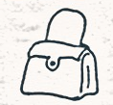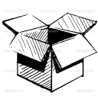 **Name the pictures :**

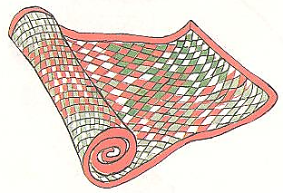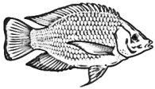

1. **Complete the sentences with a correct word in the brackets.**
2. Tom is driving a ………………………..**(bicycle , car)**
3. The cat is eating a ………………………**(rat , grass)**
4. The flower is ………………………...... **( yello , yellow)**
5. The cow is eating ……………………....**(grass , glass)**
6. **Write in capital letters.**

book …………………………………………………….

chair ……………….………..…………………………..

set ……………..………………………………………

teacher ………………..……………………………………

1. **Circle the correct word.**

vun vani van

baku buku book

table tebl teble

fudu food fod

1. **Complete the sentences with the correct word for the pictures.**

The ……………………………… is very hot.

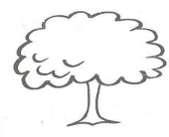

It is a big ………………………………………………



I am a …..………………………………………….



A hen has two …………….…………………..

**Handwriting.**

**HARSHTON JUNIOR SCHOOL – MBALE**

**TERM ONE HOLIDAY PACKAGE -2023**

**PRIMARY ONE *LITERACY A***

**Pupil’s Name: ………………………………………………………………….**

**SECTION A.**

1. Name **one** domestic animal.

………………………………………………………………………………………………………

1. 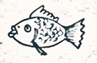Name this common food we eat.

……………………………………………………………

**(goat, fish)**

1. Circle the animal that is not found at home.

**(lion, goat, dog)**

1. 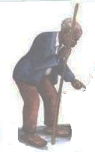**Name this person found at home.**

……………………………………………………

**(child, grandfather)**

1. 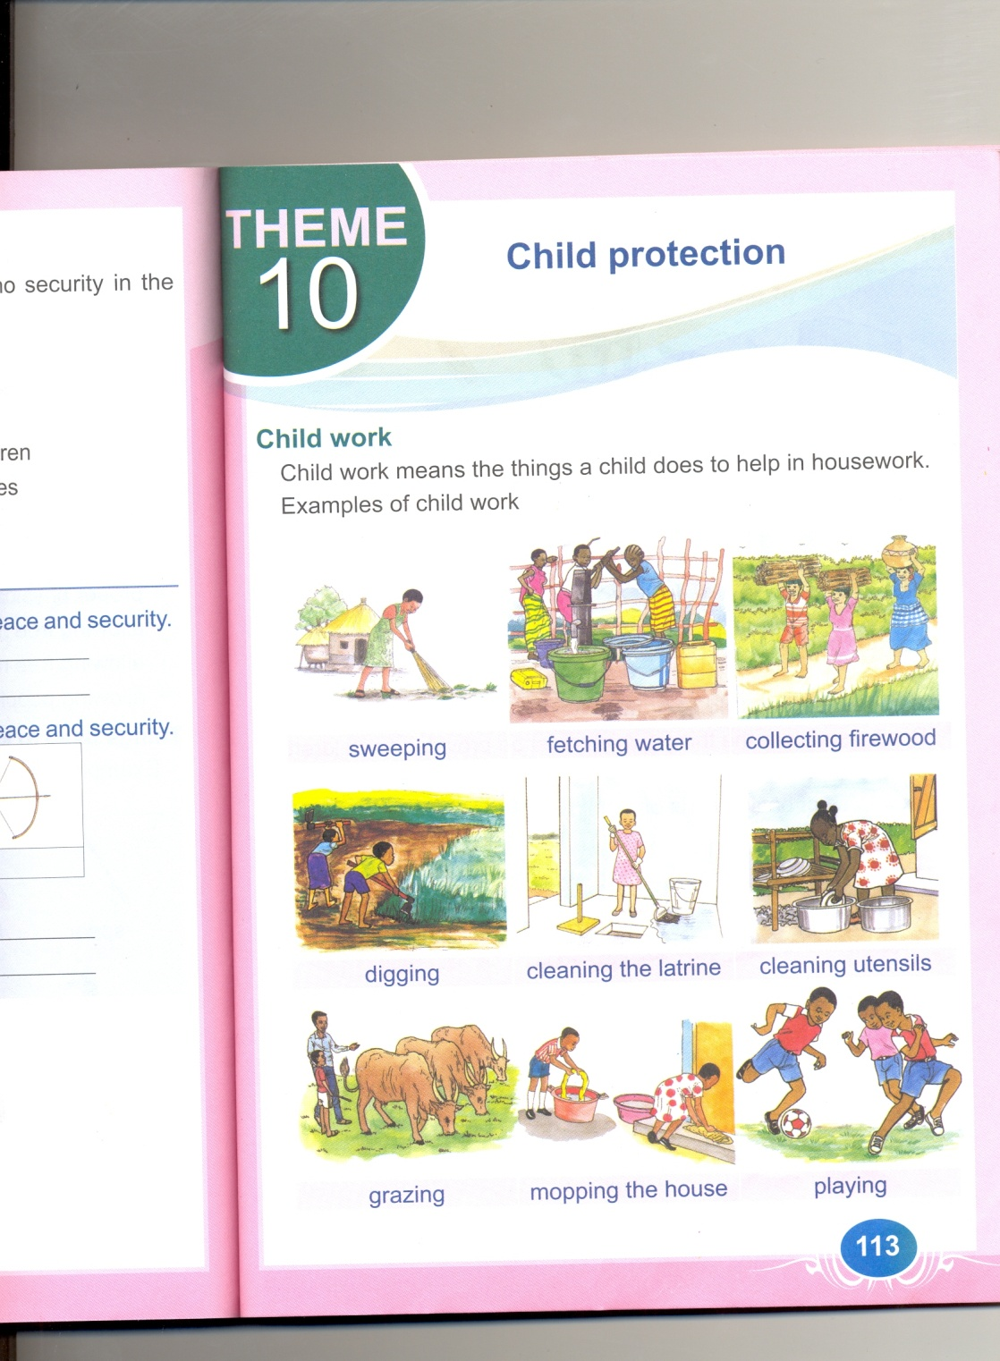**Identify this activity done at home.**

……………………………………………………

**(digging, fetching water)**

1. Underline **one** thing that we eat.

**(stones, bread)**

1. Name this thing we use to clean our home.

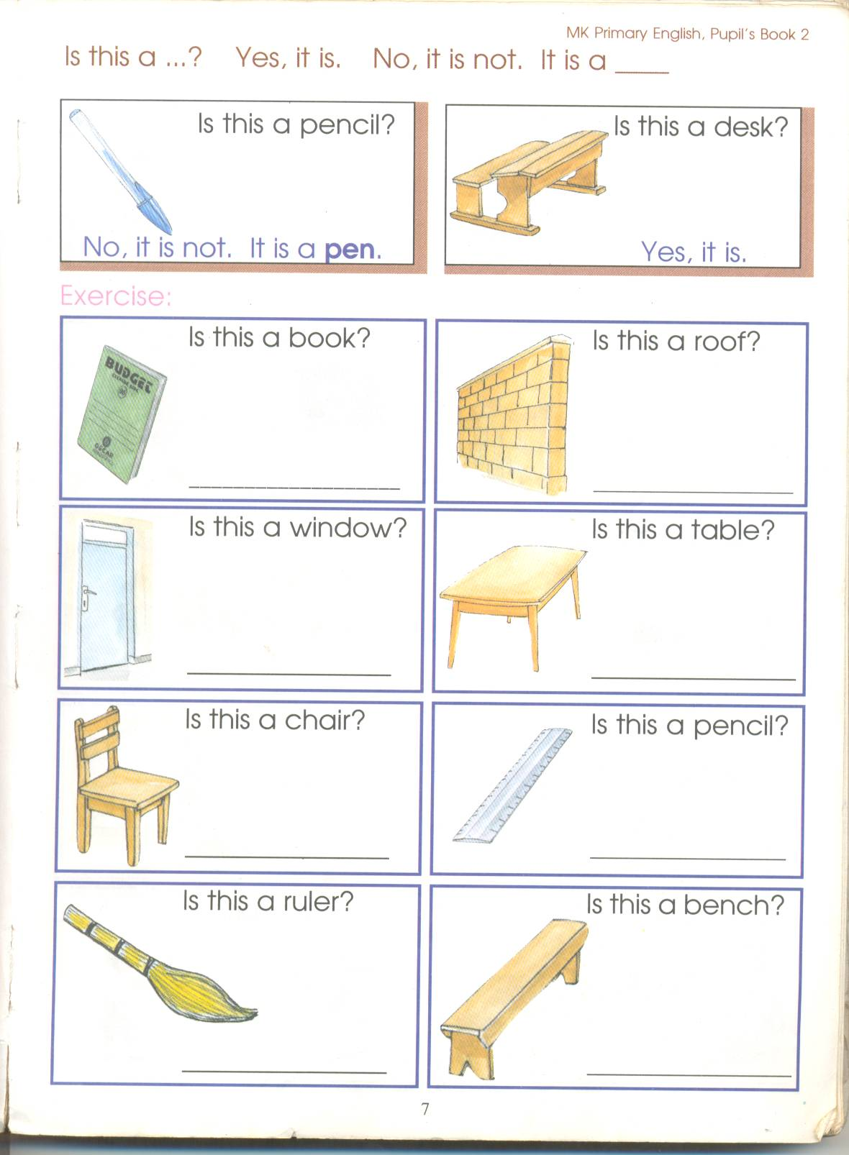 ……….………………………………………….

**(slasher, broom)**

1. What is this basic need of man?

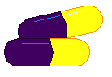

……………………………………………………

**(food, medicine)**

1. 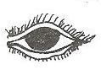Name this body part below.

………………………………………………….

**(ear, eye)**

1. State the use of the above body part

………………………………………………………………………………………………………

**(for seeing, for smelling)**

1. Name this thing found in our sitting room.



…………………………………………………

**(chair, table)**

1. 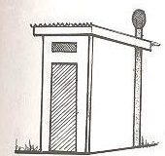Name this building found at school.

………………………………………………….

**(toilet, house)**

1. Which animal bites thieves at home?

………………………………………………………………………………………………………

**(cow, dog)**

1. 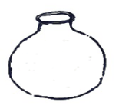Name this thing used for storing water.

……………………………………………………

**(pot, bucket)**

1. **Draw these fruits.**

|  |  |
| --- | --- |
|  |  |
| pineapple | mango |

1. Underline the part of a house.

**(door, desk)**

1. 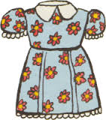Name this basic need of man.

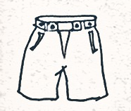

………………………………………………………..

**(food, clothes)**

1. Who heads a family?

………………………………………………………………………………………………………

**(mother, father)**

1. 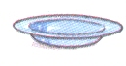Name these things used for serving food.

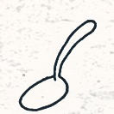…………………………………………………

…………………………………………………

(plate, ladle)

**SECTION B**

1. Match these pictures to their names.



cup



saucepan

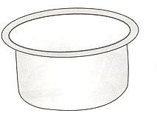

chair



table

1. Write correctly

rood: ………………………………………………………………………………………

llwa: ………………………………………………………………………………………

b) Circle the **two** people found at home.

**teacher, father, doctor, children.**

1. **Match:**

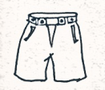water



shelter



medicine

clothes

1. **Name these parts of the body.**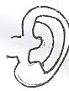

………………………………………………………



………………………………………………………

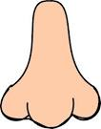

………………………………………………………

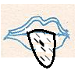

………………………………………………………

**(ear, nose, tongue, eye)**

1. **Read and draw.**

|  |  |  |
| --- | --- | --- |
|  |  |  |
| mother | father | children |

1. Who cooks food at home?

………………………………………………………………………………………………….

**(mother, father)**

1. **Name these animals found at home.**

|  |  |
| --- | --- |
|  |  |
|  |  |
|  |  |
|  |  |

**(goat, cow, cat, sheep)**

1. **Name these things we use for building.**



……………………………………………………

……………………………………………………

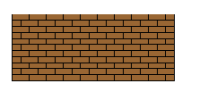

…………………………………………………….

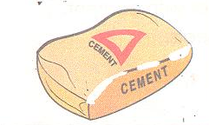

…………………………………………………….

**(nails, stones, bricks, cement)**

1. 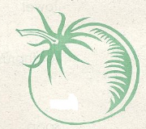Match

beans



cassava

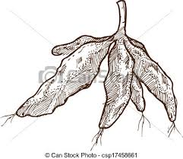

tomato

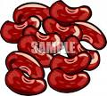

banana

1. 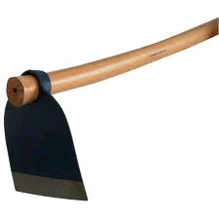**Name these things we use in the garden.**

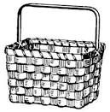……………………………………………….

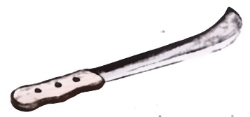……………………………………………….

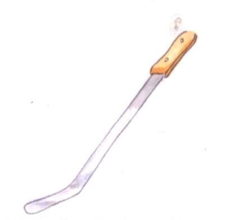

………………………………………………..

………………………………………………...

**(slasher, panga, basket, hoe)**

1. 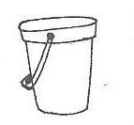**a) Match these things we use for collecting water.**

pot

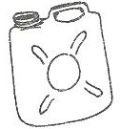

bucket

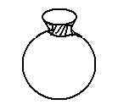

jerrycan

1. Name any **one** thing we use for cleaning water sources.

…………………………………………………………………………………………………

**(hoe, source pan)**

1. Write **“true”** or **“false”.**
2. I use my legs for walking ……………………………………………….
3. We use ears for eating …………………………………………………..
4. I use my eyes for seeing ………………………………………..
5. I use my hand for smelling ………………………….…………
6. 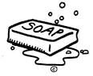Name these things we use to keep our body clean.

…………………………………………..

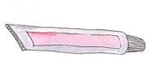

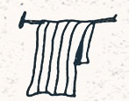…………………………………………..

…………………………………………..

……………………………………………

**(soap, towel, tooth paste, water)**

1. **Name these parts of a house.**



d

a

b

c

**(door, window, wall, roof)**

1. **Circle the things we use to clean our home.**

broom stone rake

tree hoe brick

slasher

1. **Underline the animals found at home.**

dog lion cow

elephant rabbit fox

sheep

**HARSHTON JUNIOR SCHOOL – MBALE**

**TERM ONE HOLIDAY PACKAGE -2023**

**PRIMARY ONE SOCIAL STUDIES**

**Pupil’s Name: ………………………………………………………….**

**SECTION A**

1. A ……………………………………… is a place where we go to learn. **(school, home)**
2. I go to ……………………………………………………… Junior School.
3. My name is ………………………………………………………………………………………
4. **Draw these things on our way to school**.

|  |  |  |  |
| --- | --- | --- | --- |
|  |  |  |  |
| People | trees | birds | houses |

1. Write down **two** things found in your classroom.
2. …………………………….……………….. ii) ………….…………………………………..
3. A ……………………………………… teaches pupil. **(doctor, teacher)**
4. Circle activities done at school.

**(fighting, writing, abusing, spelling)**

1. 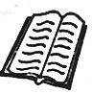**Match these correctly.**

for sitting on



for writing work



for sweeping

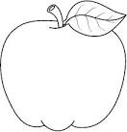

for eating

1. A ………………………………….. is a place where ………………………….. or animals live. **(people, home)**
2. Write **YES** or **NO**.
   * + - 1. A hen has two legs ……………………………………………………………
         2. A dog can fly ……………………………………………………………
         3. We go to school to learn. …………………………………………………..
         4. A father has ten eyes. ……………………………………………………………
3. A ………………………………………. heads a family. **(teacher, father)**
4. Write **three** people found at home

**(baby, thief, mother, cow, brother)**

1. ………………………………. ii)………………………….iii) ………………………………
2. Name these fruits we eat. **(Pineapple, apple, paw-paw).**

|  |  |  |
| --- | --- | --- |
| D:\Esteem Jr Sch Documents\pictures\apple.jpg |  |  |
|  |  |  |

1. Tick 4 animals that live at our home.

**(Cow, snake, dog, lion, goat, tiger, sheep)**

1. **Match these things to their names.**

sign post

NORTH ROAD P/S MBALE

forest

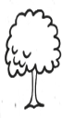

river

lake

1. Give the people who do the following at school.

Heads a school ……………………………….**(Cleaner, head teacher)**

Collects school fees………………………………….**(Librarian, bursar)**

Cares for boarders ……………………………………**(matron, Askari)**

Types work ………………………………………….. **(Director, secretary)**

1. **Match correctly.**

stockings

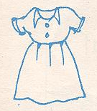

umbrella

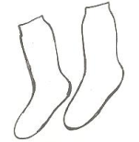

axe

dress

1. Filing the missing letters.
2. L____g ii) v ___n.
3. 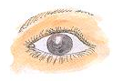Name these body parts.

___________________ ___________________

**\*\*\*\*\*\*END\*\*\*\*\*\***